Anterior Cervical Discectomy and Fusion

(ACDF)

The ACDF procedure is a very common procedure done by spine surgeons. This procedure can be done to treat a variety of conditions in the spine. Most often, it is done to treat symptoms of pinched nerves or compressed spinal cord, but it can also be used to treat traumatic injuries, tumors, infections, deformity, or degenerative conditions.

This procedure involves a small incision on the front of the neck. The important structures in the neck are carefully pulled to the sides, exposing the spine. Using a microscope, damaged disks and bone spurs are removed in order to un-pinch nerves and the spinal cord. Special wedge-shaped implants or “cages” filled with bone graft are placed in between the vertebra where the disk used to be. After that, a small metal plate and screws are used to connect the vertebrae together.

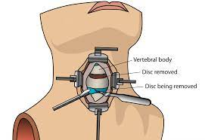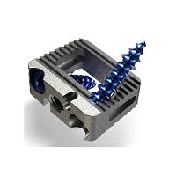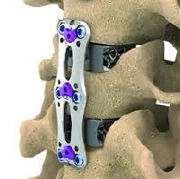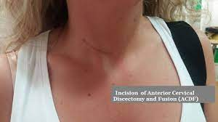

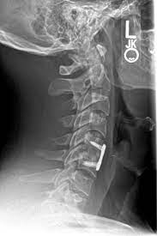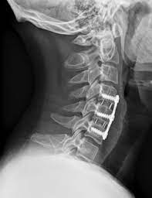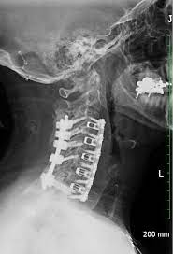

ACDF is a very common procedure, which has been used for decades to treat the spine. In its modern form, it is relatively not painful and highly successful. It can often be done on an outpatient basis or with a very short stay in the hospital. Recovery is relatively simple, and it has no affect on your legs, and minimal affect on use of your arms.

Success rates relate to the number of levels being fused. A one level fusion has nearly 100% chance of successfully fusing, but a 3-level fusion has a 45% chance of one of the levels not fusing (unless you utilize some other techniques). For this reason, 4-level fusions and some 3-level fusions may require additional implants placed through the back of the neck to provide further support and strength in order to ensure fusion.

Although other risks are low, there are some risks associated with this procedure. As with any surgery, infection, significant bleeding, and even death are possible but extremely unlikely.

The risk of nerve damage or spinal cord damage is extremely low, <1%.

One of the more common problems associated with fusion is a transient dysphagia (difficulty swallowing) that can persist for up to few weeks following the operation. However, with modern surgical techniques it is rare to see this become a long-term problem.

There is the potential for needing further spine surgery later in life. The possibility of failing to fuse is related to the number of levels being operated on, as indicated above. Failing to fuse can require a second surgery at the same spot to complete the fusion. Additionally, fusing any levels in the spine does increase the risk of needing surgery at the adjacent levels. This risk occurs at about 3% chance per year after a fusion.