Anterior Lumbar Interbody Fusion (ALIF)

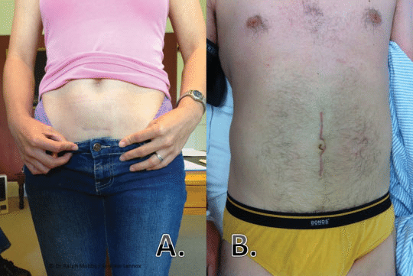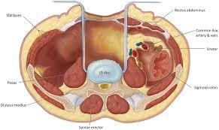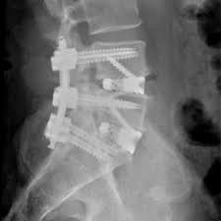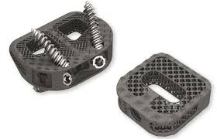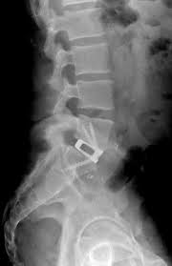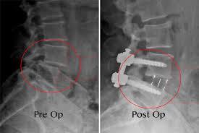

The spine is accessed through an incision in the belly, with the assistance of a vascular surgeon. After going between the abdominal muscles, the entire contents of the belly are gently pulled over to the ride side, not entering their special lining called the peritoneum, exposing the spine. The damaged disk(s) are removed, and an implant or “cage” filled with bone graft is inserted in its place. This is secured in place with integrated screws or a plate and screws. Sometimes, rods and screws are inserted through separate small incisions in the back to increase the stability and strength of the surgery.

Advantages:

* Muscle sparing approach – less painful, shorter hospital stay, faster recovery.
* Larger surface area cage – faster healing, less risk of failure.
* Nerves are not directly manipulated.
* Better restoration of the natural spinal alignment.

Disadvantages/risks:

* Accessing the spine from the front can be difficult or unsafe with prior abdominal surgeries.
* The risk of significant vascular injury is extremely low but is possible, as it is sometimes necessary to manipulate the large blood vessels that carry blood to/from your legs.
* The risk of retrograde ejaculation in men is low but possible, which can affect the ability to bear children.