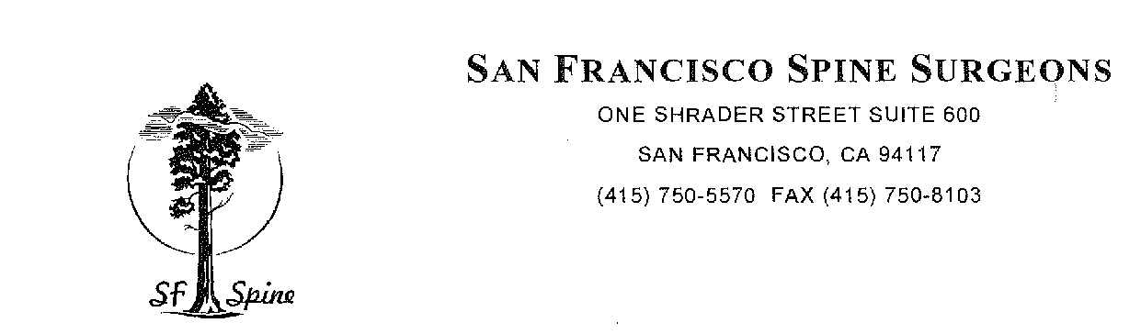
CERVICAL KEYHOLE FORAMINOTOMY

Cervical keyhole foraminotomy is a non-fusion technique to address symptoms of a pinched nerve. It is ideal when it is performed at 1 level and on one side only. It is an alternative to anterior cervical discectomy and fusion or cervical total disc replacement in treating a pinched nerve at one level. The ideal candidate would have symptoms of primarily upper extremity pain without significant neck pain, which have not improved with an appropriate period of conservative care. This procedure is not a perfect fit for all situations and cannot be used when your spinal cord itself is compressed.

Complications of posterior or posterior cervical keyhole laminotomy include, but are not limited to: risk of infection, risk of bleeding, risk of dural tear that may cause postoperative headache, risk of problems at another level, or risks of continued pain due to the same level. To ensure absolute neurological safety the surgery is done using special neurological monitoring equipment. Spinal cord injury is very uncommon but had been reported. The risk of that would be less than 1%.
