Lumbar Microdiskectomy

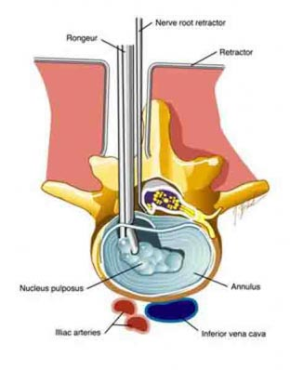

Lumbar microdiscectomy is one of the most common spine surgeries completed in the world. This procedure is done when a bulging or herniated disk pinches a nerve root, leading to pain in the buttock and down the leg. This procedure is typically completed through a small incision 1-2 inches long in the back. Usually, a microscope is utilized. A small hole is burred in the bone in order to gain access to the disk. The nerves are carefully pulled out of the way and protected while the bulging part of the disk is trimmed away. This is often completed on an outpatient basis, or occasionally with an overnight stay, depending on patient factors.

The risks of this procedure are low, but they include: infection, dural tear requiring repair, and nerve injury. The risk of nerve injury causing long term disability is very low, <1%. Although this surgery does not increase the risk that you may need further surgery later in life, it does not eliminate this risk either.

It is important to note that this surgery is almost exclusively intended to treat buttock or leg pain, and not back pain. Although some improvement in back pain can happen, it should not be expected, and treating back pain is not the primary goal of this procedure.