Transforaminal Lumbar Interbody Fusion (TLIF)

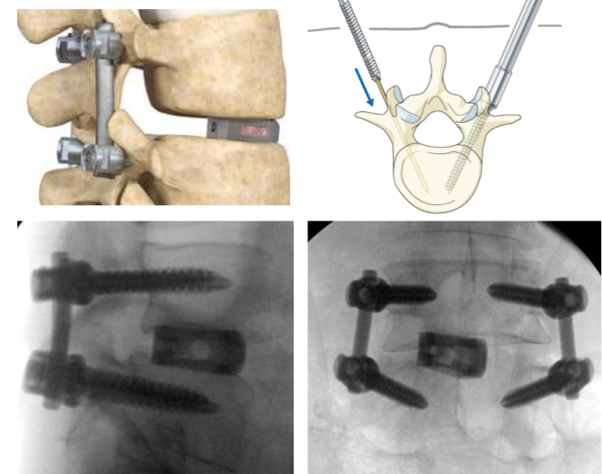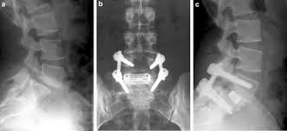

Through an incision in the back, bone and ligament are removed to un-pinch nerves. Disk is removed, and a spacer or “cage” filled with bone graft is placed in between the vertebra to provide support and encourage bone growth. Screws are placed into the vertebra above and below this, and rods connect them together to eliminate motion.

Advantages:

* All work is done through one incision in the back
* “Workhorse” procedure, can be accomplished in a variety of scenarios and for a variety of problems.
* Has been used for decades with excellent results.

Disadvantages/risks:

* Muscle splitting approach can cause back pain, and a slower recovery than other approaches.
* Risk of nerve injury is very low but does exist, as the nerves are directly visualized and manipulated in this surgery. Special nerve monitoring equipment is used throughout the procedure to minimize these risks.
* It can be more difficult to restore the natural shape of the spine from this approach.
* The risk of further spine surgery is always present, on the same level due to problems, or on adjacent levels.