Lateral Interbody Fusion

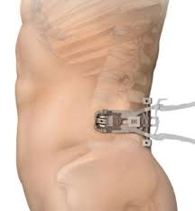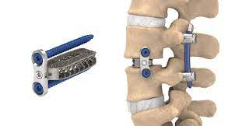

Through a small (~2 inches) incision on the side, the damaged disk is removed from between two vertebrae. A spacer or “cage” filled with bone graft is inserted in its place, to support the vertebra and encourage bone growth. A metal plate and screws are added to eliminate motion, or in some cases screws and rods can be added through separate small incisions for added strength and support.

ADVANTAGES:

* Muscle sparing, less painful, faster recovery, shorter hospital stay.
* Nerves are not directly manipulated.
* Large cages with increased surface area for more support and better bone growth.
* Good at recreating the natural shape of the spine.
* Very low infection risk

DISADVANTAGES/RISKS:

* Temporary weakness in hip flexion or knee extension is not uncommon, although permanent weakness is exceedingly rare. Special nerve monitoring equipment is used throughout the surgery to minimize these risks.
* Some numbness on the front of the thigh can occur and can rarely be permanent.
* Certain spine problems can be difficult to fix with this approach.